Requirements Definition

*FooBar*

**1. Introduction and Context**

Dan’s Bagel Shop is a soon to be opened bagel store featuring a lovely selection of bagels, shmears, sammiches, and beverages. There will be a single store location which will prepare and distribute bagels to eager customers. This document will outline and describe the requirements provided by Dan of Dan’s Bagels.

As a bagel shop, Dan’s Bagels would like to make the process of placing, obtaining, and paying for bagel orders a quick, easy, and convenient process. Customers will be able to place orders online or through kiosks at the store. When orders are placed they will be sent to cooks who will prepare the order using the application to access inventory. When an order is ready to be picked up, the application will notify the customer. When the customer arrives a cashier will use the application to dispense the order and charge the customers Dan’s Bagel account. If the customer enjoys their bagel the application will make reordering quick and easy.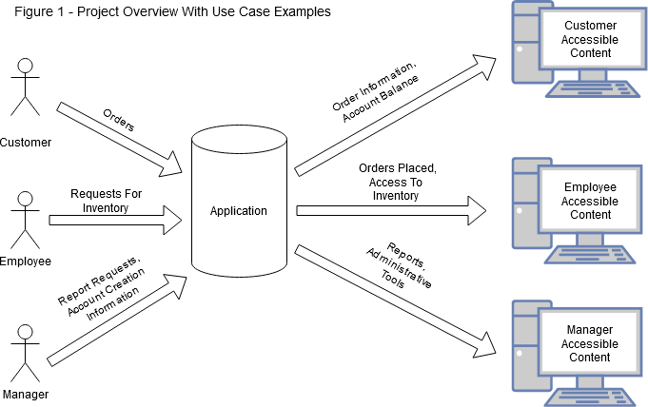

The application will also help the business run smoothly. A database will store account information, orders, and inventory. There will be Manager, Customer, Chef and Cashier accounts. The application will track inventory as well as sales information. The application will also track information regarding a customer rewards program. The application will be able to generate reports for the Manger and track inventory expiration information. Users will interact with the application through a web browser that supports a minimum of html5, css3, and ecmascript 2015.

**2. Users and their Goals**

**Customers:**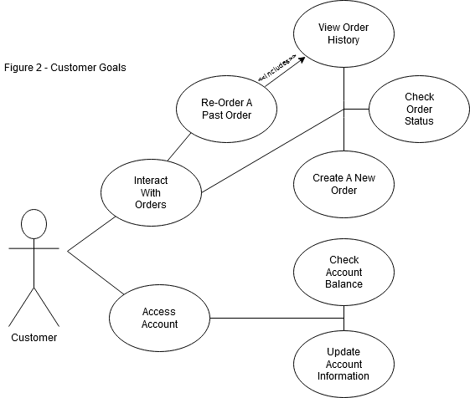

**Chefs:**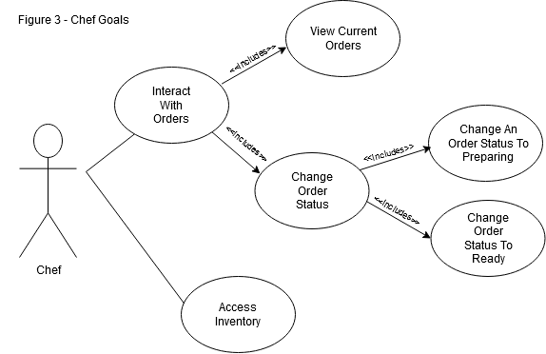

**Cashiers:**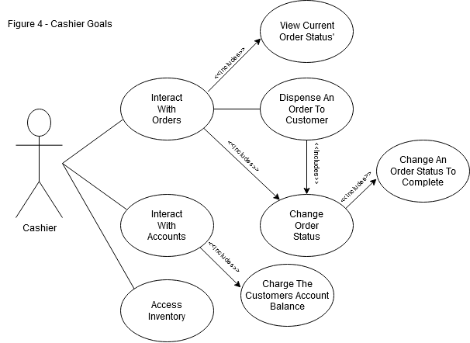

**Managers:**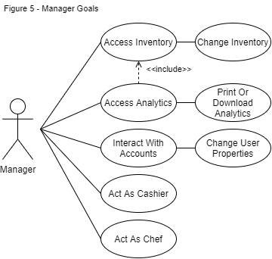

**3. Functional Requirements**

1. The product will be a web based application that can load on browsers.
2. Inventory Tracking

2.1 Initial value of 100 for each inventory item

2.2 Minimum Inventory Categories

2.2.1 Bagels ($2 each)

2.2.1.1 Plain

2.2.1.2 Onion

2.2.1.3 Cinnamon raisin

2.2.1.4 Sesame

2.2.1.5 Cheesy

2.2.1.6 Pumpernickel

2.2.2 Shmears ($1 each)

2.2.2.1 Plain

2.2.2.2 Honey Nut

2.2.2.3 Strawberry

2.2.2.4 French Onion

2.2.3 Sammiches

2.2.3.1 Bagel + Bacon ($1)

2.2.3.2 Egg ($2)

2.2.3.3 Cheese ($1)

2.2.3.4 Sausage ($2)

2.2.3.5 Avocado ($10)

2.2.3.6 Turkey ($2)

2.2.3.7 Ham ($2)

2.2.3.8 Spinach ($1)

2.2.3.9 Tomato ($1)

2.2.3.10 Lox ($10)

2.2.4 Beverages

2.2.4.1 Coffee ($2)

2.2.4.2 Milk ($2)

2.2.4.3 OJ ($2)

2.2.4.4 Water ($5)

1. Accounts

3.1 Customer

3.1.1 Place orders

3.1.2 View order history

3.1.3 Reorder past orders

3.1.3.1 This action takes a single button click

3.1.4 View account balance

3.1.5 View reward information

3.1.6 View order status

3.1.7 Adjust account information

3.1.7.1 Change Name

3.1.7.2 Change Email

3.1.7.3 Reset Password

3.1.8 Prepopulated with $100 account balance.

3.2 Manager

3.2.1 Manage employee and customer accounts

3.2.2 Make changes to menu

3.2.3 Approve creation of Chef and Cashier accounts

3.2.4 Add money to account balances

3.2.5 Modify existing account type (IE Customer becomes an employee)

3.2.6 Remove Cashier and Chef role from account (IE Employee is let go)

3.2.7 Able to adjust inventory

3.2.7.1 Add to inventory amounts (Buy more)

3.2.7.2 Add new inventory types

3.2.8 View reports and analytics

3.3 Chef

3.3.1 Chef account is approved by manager account

3.3.2 Able to decrement inventory when preparing a dish

3.3.3 Able to change order status (to Preparing or to Ready)

3.3.4 Able to view an orders status

3.4 Cashier

3.4.1 Able to decrement account balance

3.4.2 Able to view order status

3.4.3 Able to change order status

3.4.4 Verify User account information

1. System Capabilities

4.1 Transactions are denied if account balance is too low

4.2 Notify Customer if a desired order cannot be made (Lack of inventory)

4.3 Notify Chef 10 minutes before order pick up time

4.4 Report needed/expired inventory.

**4. Non-functional Requirements**

1. The product will be able to load on the most commonly used browsers.
2. The customer experience will be convenient and user friendly.

2.1 Orders can be placed 2 days in advance.

2.2 Orders can be canceled at any time before an order is marked “Prepared”.

2.3 The customer will be notified of order status changes in a timely manner.

2.4 Customer account creation will not need approval from the Manager account.

1. The database will be quick, reliable and have minimal hardware requirements.

3.1 The database will be able to run in the cloud

1. Reports will display information in a clear and organized manner.
2. The application will support 100 simultaneous users.
3. The server will support 10 simultaneous requests.
4. The reward system will provide a free bagel after 12 purchases.

**5. Future Features**

1. Favorite orders can be saved to Customer Accounts.
2. Items can be marked as popular to send to the top of the menu.
3. Suggestion/ comment box to be used by customers.
4. Customers are able to leave a review.
5. Expiration of inventory/specials for soon to be expired
6. A debug mode for support and maintenance

**6. Glossary**

1. Inventory: The amounts of food and or product stored at Dan’s Bagel Shop. This Inventory is also referred to as a point in the database that stores the amounts stored on site.
2. Analytics; The history of orders and inventory that will be formatted into a report so the Manager can easily see necessary information about sales and supply.
3. Database; A virtual location stored on the server that stores values for Inventory and or values of user accounts.
4. Application; The website itself.
5. Sammiches; Sandwiches
6. Role: A tag on a User account used to restrict access